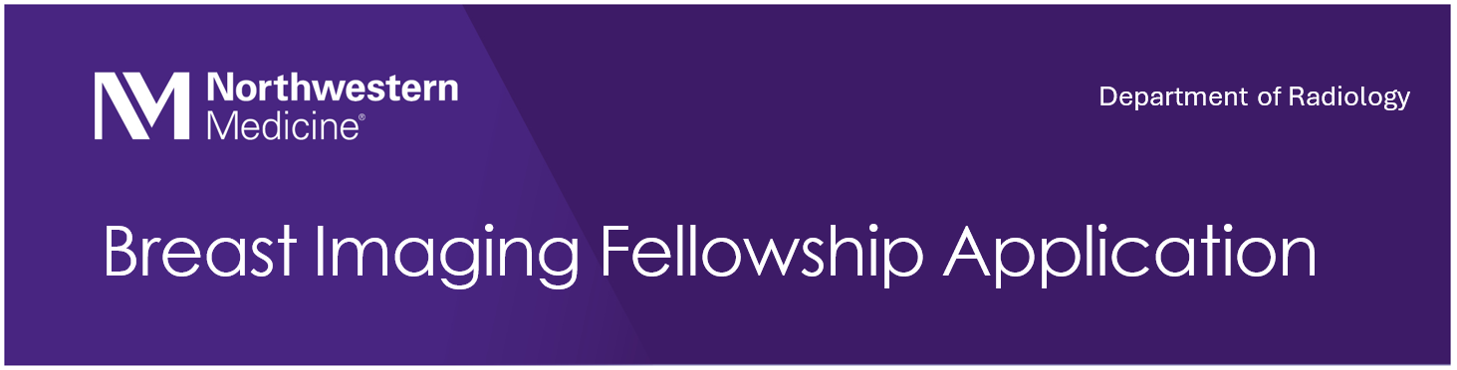
Northwestern Breast Imaging Fellowship Application

Application Checklist

- Northwestern Breast Imaging Application
- Personal Statement
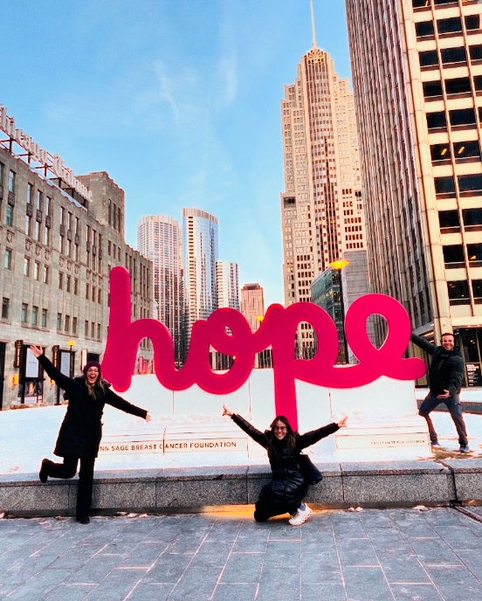
- CV
- USMLE Transcript
- Medical School Transcript
- 3 Letters of Recommendation

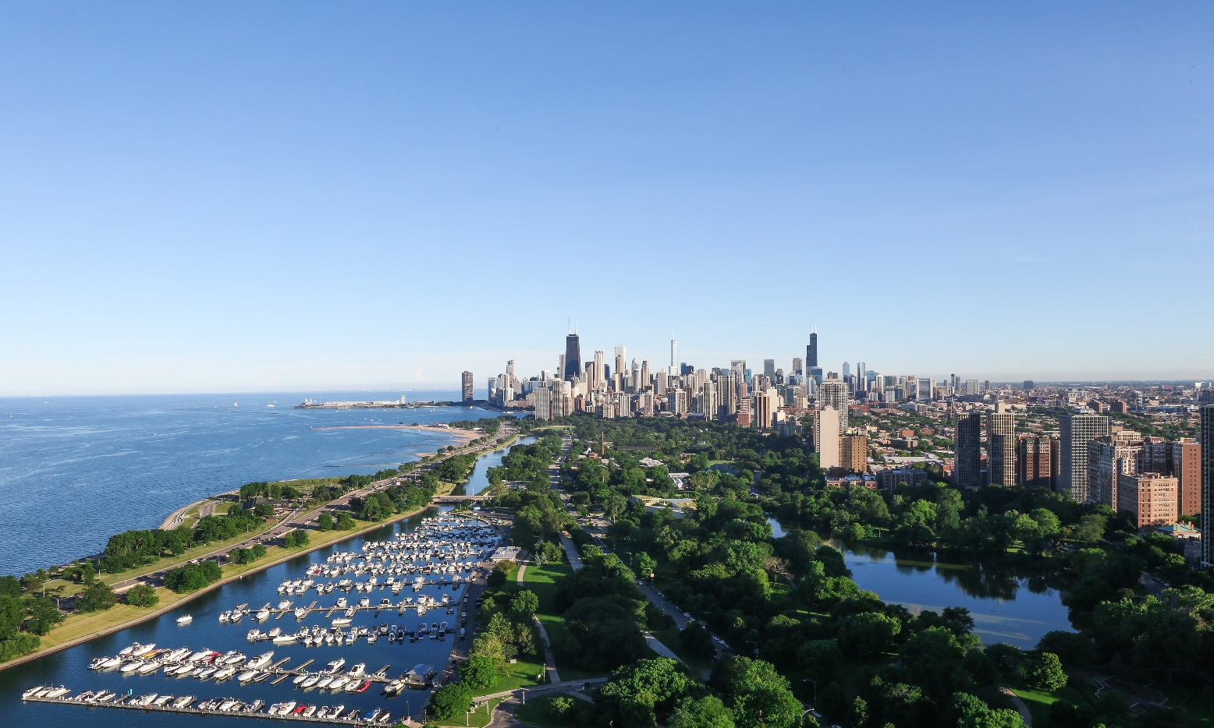

Applicant Information:

Name:
Present Address:
Permanent Address:
Email:
Telephone:

Education/Training/Research:
Please include any additional applicable training or research by adding rows
 | Institution/Location | Dates of Attendance (MM/YYYY – MM/YYYY) | Field of Study | Degree
Premedical Education
Medical Education
Internship PGY1 Training
Radiology Residency

Examinations:

United States Medical Licensing Examination (USMLE): Copies must be sent to individual programs
Step 1:
Step 2:
Step 3:

Comprehensive Osteopathic Medical Licensing Examination (COMPLEX): Copies must be sent to individual programs
Level 1:
Level 2-CE:
Level 2-PE:
Level 3

Educational Commission for Foreign Medical Graduates Exam (ECFMG): Copies must be sent to individual programs
Where taken:
Date:
Certificate Number:

Medical Licensure:
State and Expiration Date:

Letters of Recommendation:
Please list names and contact information of the 3 preceptors that will be providing a letter of recommendation, one of which must come from your diagnostic radiology residency program director. These letters must be sent directly to the programs from the letter author.
Name | Title and Institution | Email

Background:
Have you been charged with or convicted of a crime (other than a minor traffic offence) in this or any other state or country? Yes or No
Have you had disciplinary actions taken against you by your medical school, internship, or residency program? Yes or No
Are there any special circumstances that should be considered when reviewing your application? Yes or No

Application Certification specific to Northwestern:
Northwestern Medicine is unable to offer positions to J1 or H1-B visas for this application cycle. Can you please acknowledge? Yes or No
Northwestern Breast Imaging Fellowship participates in the NRMP Match facilitated by the Society of Breast Imaging. Can you please acknowledge? Yes or No

Signature:

Date:

